**Challenge1**

**Index.html**

<!DOCTYPE html>

<html lang="en">

<head>

    <meta charset="UTF-8">

    <meta http-equiv="X-UA-Compatible" content="IE=edge">

    <meta name="viewport" content="width=device-width, initial-scale=1.0">

    <title>Advanced Topics</title>

</head>

<body>

    <script src="challenge1.js"></script>

</body>

</html>

**Challenge1.js**

const myArray=[];

myArray.push(10);

myArray.push(20);

myArray.push(30);

myArray.push(40);

console.log("Before: "+ myArray);

myArray.pop();

console.log("After: "+ myArray);

**Result**

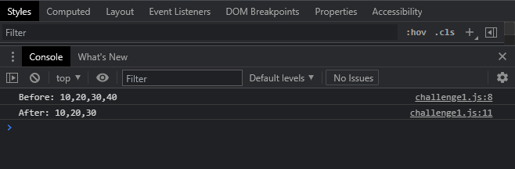

**Challenge2**

**Index.html**

<!DOCTYPE html>

<html lang="en">

<head>

    <meta charset="UTF-8">

    <meta http-equiv="X-UA-Compatible" content="IE=edge">

    <meta name="viewport" content="width=device-width, initial-scale=1.0">

    <title>Advanced Topics</title>

</head>

<body>

    <script src="challenge2.js"></script>

</body>

</html>

**Challenge2.js**

const myObject={

    name:"indra",

    age:22

};

console.log(typeof myObject);

const myArray=[10,20,30];

console.log(typeof myArray);

**Result**

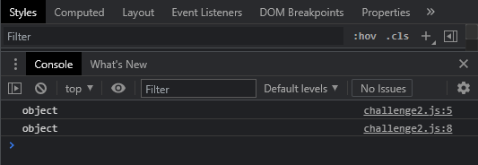

**Challenge3**

**Index.html**

<!DOCTYPE html>

<html lang="en">

<head>

    <meta charset="UTF-8">

    <meta http-equiv="X-UA-Compatible" content="IE=edge">

    <meta name="viewport" content="width=device-width, initial-scale=1.0">

    <title>Advanced Topics</title>

</head>

<body>

    <script src="challenge3.js"></script>

</body>

</html>

**Challenge3.js & result**

console.log("indra" instanceof Number);//false

console.log("indra" instanceof String);//false

console.log("indra" instanceof Boolean);//false

// console.log("indra" instanceof null);//challenge3.js:4 Uncaught TypeError: Right-hand side of 'instanceof' is not an object

// console.log("indra" instanceof undefined); //Uncaught TypeError: Right-hand side of 'instanceof' is not an object

console.log(10 instanceof Number);//false

console.log(10 instanceof String);//false

console.log(10 instanceof Boolean);//false

// console.log(10 instanceof null);//challenge3.js:4 Uncaught TypeError: Right-hand side of 'instanceof' is not an object

// console.log(10 instanceof undefined);//challenge3.js:4 Uncaught TypeError: Right-hand side of 'instanceof' is not an object

console.log(false instanceof Boolean);//false

// console.log(null instanceof null);//Uncaught TypeError: Right-hand side of 'instanceof' is not an object

// console.log(undefined instanceof undefined); //Uncaught TypeError: Right-hand side of 'instanceof' is not an object

**Challenge4**

**Index.html**

<!DOCTYPE html>

<html lang="en">

<head>

    <meta charset="UTF-8">

    <meta http-equiv="X-UA-Compatible" content="IE=edge">

    <meta name="viewport" content="width=device-width, initial-scale=1.0">

    <title>Advanced topics</title>

</head>

<body>

    <script src="challenge4.js"></script>

</body>

</html>

**Challenge4.js**

const myObject= new Object();

console.log(typeof myObject);

console.log(myObject instanceof Object);

console.log(myObject instanceof Function);

const myFunction= function(){

    console.log("In Function");

}

console.log(typeof myFunction);

console.log(myFunction instanceof Object);

console.log(myFunction instanceof Function);

**Result**

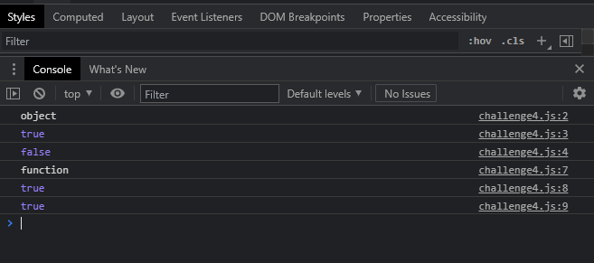

**Challenge5**

**Index.html**

<!DOCTYPE html>

<html lang="en">

<head>

    <meta charset="UTF-8">

    <meta http-equiv="X-UA-Compatible" content="IE=edge">

    <meta name="viewport" content="width=device-width, initial-scale=1.0">

    <title>Advanced topics</title>

</head>

<body>

    <script src="challenge5.js"></script>

</body>

</html>

**Challenge5.js**

console.log("Globale Execution Context-root level");

function firstLevel(){

    console.log("Function Execution Context-first level");

    function secondLevel(){

        console.log("Function Execution Context-second level");

        function thirdLevel(){

            console.log("Function Execution Context-third level");

            console.log("Exiting third level");

        }

        thirdLevel();

        console.log("Exiting second level");

    }

    secondLevel();

    console.log("Exiting first level");

}

firstLevel();

console.log("Exiting root level");

**Result**

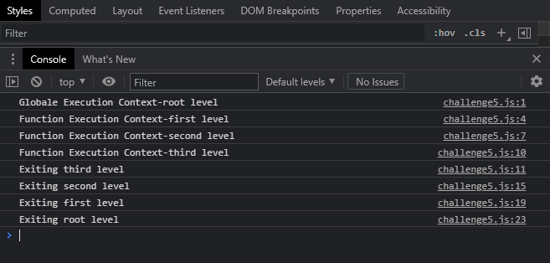

**Challenge6**

**Index.html**

**Challenge6.js**

**Result**

**Challenge7**

**Index.html**

**Challenge7.js**

**Result**